Douglas County, NV

Request for Proposals

Enterprise Resource Planning
(Financial, Human Resources & Utility Billing)
July 31, 2023

Douglas County
1594 Esmeralda Ave
Minden, NV 89423
Request for Proposals
ERP Software Selection
(Financial, Human Resources & Utility Billing)

Douglas County, NV (“County”) is evaluating new software to satisfy its Finance, Human Resources, and Utility Billing information management applications needs.
Response instructions are contained in Sections 3, 4, 5, and 6 of the Request for Proposals (RFP) document.
Section 5 of the RFP contains feature/function and other information worksheets. Please complete these worksheets using the electronic forms (Excel format) and as directed in the RFP instructions. The electronic forms have been locked where possible to ensure the integrity of the information.
The proposal should include all costs associated with training, implementation, hardware specifications, interface estimates, file-conversion assistance, custom modification estimates, annual maintenance, and support.
- Send the intent to propose notification to Terri Willoughby, Chief Financial Officer (County Point of Contact, “POC”) by email to twilloughby@douglasnv.us no later than August 14, 2023.
- Send any questions related to this RFP in writing to the POC via email no later than August 21, 2023. Only written questions submitted by email by the above-stated date will be accepted.
- Please submit your proposal by 4:00 PM (PT) September 8, 2023, as follows:
  - One (1) copy emailed to the POC at twilloughby@douglasnv.us
  - One (1) copy electronically on a flash drive to:
Terri Willoughby
Chief Financial Officer
Douglas County
1594 Esmeralda Ave
Minden, NV 89423
Thank you for your participation. We look forward to reviewing your proposal.

Table of Contents
1. Project Objectives and Process 5
1. Purpose 5
2. Objective 8
3. County Background 8
4. System Functionality Requirements 10
5. Process and Schedule 11
2. Evaluation Criteria 12
3. Specific Response Requirements 13
1. Programming Languages 13
2. Operating Systems 13
3. Database 13
4. User Interface Configurations 13
5. Reporting Capabilities 13
6. Electronic Content/Document Management Capabilities (ECMS) 13
7. Workflow Capabilities 13
8. Application Security 14
9. Application Software 14
10. Software Upgrades 14
11. User-Access Requirements by Module 15
12. Hosted/SaaS Model 15
13. Vendor Hosted/SaaS Contract Term 15
14. Hardware Requirements 16
15. Integration/Interface Capabilities 16
16. Cost Considerations 19
17. Mobile Field Computing 19
18. Maintenance and Support 19
19. Implementation Methodology 19
20. Conversion Costs 20
21. Training and Education 21
22. Project Management 21
23. Subcontractor and Third-Party Relationships 21
24. Customer Implementation Responsibilities 21
25. Sample User and Technical Manuals & Other Documentation 21
26. Vendor/Reseller Information 21
27. Technology Direction 22
28. Vendor Financial Information 22
29. User Groups 22
30. References and User Base 22
4. Volumes 23
1. User License Information 23
2. Volumes Information 23
5. Proposal Forms & Supporting Information 25
1. Vendor Electronic Response Files 25
6. Proposal Instructions 26
1. General Proposal Instructions 26
2. Proposal Format 27
7. Disclosures & Contractual Requirements 28
1. Bulletins and Addenda 28
2. Rejection of Proposals 28
3. Acceptance of a Proposal 28
4. Insurance 29
5. Vendor Demonstrations 29
6. Qualifications 29
7. Acknowledgments 30

- Project Objectives and Process
- Purpose
This information was developed to facilitate the preparation of a proposal in response to this RFP and the subsequent evaluation of that response.
The County currently utilizes the following core systems:
- Financial Management
  - New Worlds Systems
    - Accounts payable
    - Bank reconciliations
    - Budgeting (including salary/benefits, projects)
    - Cash receipts
    - Fixed asset management
    - General ledger/journal entries
    - Requisitions/purchase orders
  - ClearGov (capital improvement budgeting)
- Human Resources Management
  - New World Systems
    - Human resources
    - Payroll
  - NEOGOV
    - Employee onboarding, recruitment, performance evaluation
  - E-Suite
    - Employee information
    - Open enrollment
    - Paystubs
    - Timesheet entry
    - W2s
- Utility Billing & Customer Information Management
  - New World Systems
    - Customer information
    - Utility billing
    - Work orders
  - E-Suite
    - Customer portal
In addition to these core systems, the County relies on other software, tools, and services for conducting its business. Some of these tools are:
- Adobe
  - Audit trail for vouchers
  - Digital signatures (vouchers and purchase orders)
  - Fixed asset documentation
  - Purchase order requests
- Aladtec
  - Employee scheduling
  - Leave, shift trade, and overtime request management
- Bank of America
  - Monthly procurement card transaction imports
- Caselle
  - Utility billing
  - Cash receipts
- CivicRec Recreation Management
  - Cash receipts
- DebtBook
  - Track amortization and payments
  - Journal entry preparation
- Dropbox
  - Department claim voucher submissions
  - Procurement card voucher submissions
- Government Software Assurance
  - Property tax billing
- Helion
  - Cash receipts document management
- ICE
  - Third-party worker’s comp administration
- Infinisource
  - Third-party COBRA administration
- Karpel Solutions
  - Case management
  - Cash receipts
- Microsoft Excel:
  - Bank reconciliations
  - Due to/from account processing for payroll entries
  - Fixed asset processing
  - Grant submission processing
  - Miscellaneous revenue tracking and receipting
  - Procurement card activity tracking
  - Project budget request processing
  - Purchase order balance tracking
  - Reporting
  - Timesheet processing
  - Voucher creation and tracking
- MyBridgePay
  - Utility billing credit card processing
- Pay Guardian
  - Utility billing credit card processing
- QuickBooks
  - Billing
  - Cash receipts
- Sensus
  - Utility billing meter reads
- Tyler
  - Business Analytics (New World Systems)
  - Utility billing credit card processing
- WAM
  - Utility billing
  - Cash receipts
- WorkWave
  - Weed billing
  - Cash Receipts
The goal of the County is to procure and implement integrated enterprise resource planning, utility billing and customer information systems that utilize best practices, the latest technology, automated workflow, as well as improved and simplified reporting.
The County recognizes that vendors may not offer all of the software suites defined in Section 4 herein. Vendors are encouraged to propose a solution with software partners in order to meet the County’s desire for an integrated solution under a single contract with one parent vendor (See Section 3, Subsection 22). Vendors who do not have Utility Billing capability will not be penalized. Utility Billing-only vendors that meet the County’s needs are also encouraged to propose their solution.
The final decision will be based on various evaluation criteria, primarily how well the proposed solution meets the County’s overall functional requirements. The requirements noted in this RFP are designed to meet these objectives.

Objective
The objectives for this project are to:
- Improve customer service and relations
- Reduce manual processes and increase productivity
- Improve internal processes by automating routine tasks
- Reduce paper-based workflows
- Improve integration with other systems
- Select and implement a supportable solution
- Improve customers’ ability to interact and do business with, and in the County
- Take advantage of newer technology
The County is looking for the best overall solution to meet its current and future needs. It is understood that there are no perfect solutions, and that the applicable vendor may vary in its capability to meet the County’s overall system needs.
- County Background
The County covers an approximate area of 751 square miles, and is located in the western portion of the State. The County provides its citizens with public safety protection, water and wastewater systems, parks, libraries, senior and community services, courts, maintenance of rural roads, social welfare, a regional airport, and several state-mandated duties.
Some County statistics are identified in the table that follows:
County General Fund Budget FY23 | $53,454,378
County Capital Improvement Plan Budget FY23 | $9,901,302
County Total Budget FY23 | $117,234,814
Number of Employees (FTE) | 500
Number of Permanent Part-Time Employees | 69
Population (2021) | 49,870
Below is the County’s Organizational chart, as presented in its FY2022 Budget book:

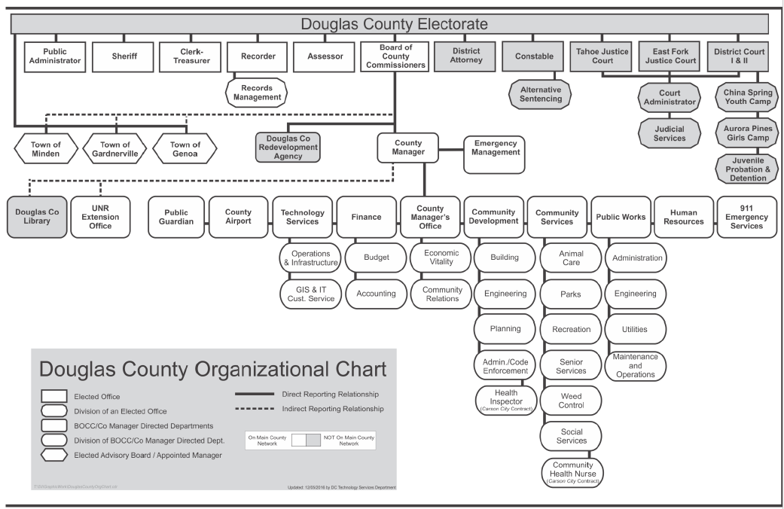

System Functionality Requirements
The County is looking for an integrated system, which is to include the following primary functionality (modules). This list is not intended to be all-inclusive/exclusive.
Financial
- General Ledger
- Bank Reconciliations
- Budgeting (General, Salary, and Capital)
- Project Accounting
- Requisitions and Purchasing
- Accounts Payable including Purchasing Cards
- Accounts Receivable and Miscellaneous Billing
- Cashiering
  - Including customer online payments
- Fixed Assets
- Financial Reporting
Human Management
- Human Resources
  - General HR and Risk Management
  - Benefits Administration
  - Employee Self-Service Portal
- Time & Attendance
- Payroll
Utility Billing/Customer Information
- Customer Information/Service and Billing
- Service/Work Order Management (Includes Meter Reading)
- Cash Handling
Other
- Reporting – Ad Hoc
- Integrations (please reference Appendix H for specific requirements)
  - GIS
  - Parcel/Address Management
The County seeks to install the system utilizing the vendor to provide all services, including software, installation, process discovery, training, project management, interfaces, conversion assistance, maintenance, and support. Applicable hardware specifications with sizing documentation should also be provided.

Process and Schedule
The process is for the County to review the proposals, evaluate the solutions, and finalize a project scope of work. The County will then make a final decision using subsequent interviews, demonstrations, reference checks, and/or site visits.
Selection Process Step | Estimated Date(s)
Release and Issuance of the Request for Proposal (RFP) | July 31, 2023
Notification by Vendors of Intent to Respond | August 14, 2023
Final Date for Vendors to Submit Questions | August 21, 2023
Date for Publishing Answers to Vendors’ Questions | August 28, 2023
Proposals Due | September 8, 2023
Decision on Vendor Finalists (short-list) | October 2023
Demonstrations by Vendor Finalists | November 2023
User Site Visits/Reference Checks | December 2023
Final Vendor Selection | December 2023 – January 2024
Contract Negotiation Process | January – March 2024

- Evaluation Criteria
The County reserves the right to select the vendor who best meets the overall needs of the County, based primarily on the following criteria (not listed in any order of importance):
- The overall ability to provide the required software features and capabilities.
- The flexibility of the application software, including the availability of tools to allow the novice user to “drill down and across” and perform ad hoc analysis and reporting.
- The amount of vendor support that will be available for installation, conversion, training, ongoing modifications, bug/issue resolution, and software support.
- Existing customer feedback regarding responsiveness of vendor support.
- The total costs of the system over a ten-year period, including direct and indirect costs.
- The vendor's performance record to date in meeting the requirements of their existing customers, including the availability of users similar to the County to allow for a reference investigation.
- The expandability of the proposed solution, including the ease of upgrading the proposed system by adding components to accommodate future needs.
- Adherence to the requested information specifications and thoroughness of the proposal, as well as the overall format of the presentation.
- The financial stability, longevity, and strength of the vendor.
- Corporate direction (potential organizational/industry restructurings, mergers, acquisitions, etc.).
- Future technology direction (major changes in architecture, database, platforms, languages, etc.).
- The internal controls provided within the system which prevent unauthorized access to data and provide adequate audit trails.
- The ability to perform required conversions of existing data files.
- The seamless integration of the various system modules and ability to meet the interface/integration requirements noted in this RFP.
- Ease and intuitive use of software interface (for both internal staff and Web customers).
- Availability and ease of use of mobile and online applications.
- Ability to meet contract requirements.
- The percentage of time your cloud solution is operational.
- Specific Response Requirements
Include the following items in the order listed below (and indexed in the same manner) in your response to this Request for Proposals (RFP). Please respond to each issue in detail regarding how the proposed solution satisfies each concern.
- Programming Languages
Please provide information on all programming languages used for each proposed required application.
- Operating Systems
Please provide a description of the proposed server and desktop operating systems used by your products and which server software option is being proposed (include server software name, year, and version).
- Database
The County expects the information system to be based on a very stable and flexible relational database standard. The County’s preference is MS SQL. Please briefly describe the relational database platforms available in the use of your products and which database option(s) are being proposed (include database management system name, year, and version).
- User Interface Configurations
The County desires to move forward with advancing technologies and prefers a solution that is a web-based application and browser/operating system agnostic that can be run on desktop and mobile platforms. Screen-scraper technology configurations will not be considered. Please describe your client architecture.
- Reporting Capabilities
Please provide information on overall system/solution reporting capabilities (e.g., canned reports, financial reporting, ad hoc reporting, executive dashboard, etc.). Please define the reporting architecture that is used (SSRS or other[s]).
- Electronic Content/Document Management Capabilities (ECMS)
Please provide information regarding how files are attached and stored from within your proposed system at multiple levels (e.g., invoices, requisitions, employee files, etc.).
- Workflow Capabilities
Please provide information on your system's workflow capabilities. Describe the integration level with all systems. If you have no workflow capabilities, please indicate.

Application Security
Please describe application and user security features/capabilities. Indicate any special security features (e.g., user/role security, function security, file security, field-level security, etc.) provided by the software. Please also confirm your support of Active Directory and if you provide Single Sign On (SSO) capabilities.
- Application Software
Please complete the Software Features, Functions, and Capabilities Listing contained in the electronic file provided with the RFP Section 5 (Appendices A).
The proposed software should demonstrate an online, integrated method of processing the noted application modules and allow for immediate update of all information. Access to information in either summary or detail should be obtained easily and intuitively. The proposed software’s data entry screens should be user-friendly and utilize established standards of user-interaction design to facilitate rapid data entry.
For each application software module proposed, indicate whether your organization developed the module, or if the module is available because of a third-party relationship that has been established with another vendor.
In addition to the required and optional software information requested in Section 5, provide general information on other application modules not requested in this RFP which may be of interest or benefit to the County.
- Software Upgrades
Please describe your software versioning and update polices/practices. Include, at a minimum, how often you issue updates (new versions) and whether new versions are provided as part of your annual maintenance and support fees. Please explain the process of installing update patches and service packs. Please provide costs related to the following upgrade items.
Upgrade Types | Typical Frequency  (in months) | Typical Vendor Assistance Cost |  | Typical Vendor End-User Training
 |  | Low Cost | High Cost | Low Cost | High Cost
Version Upgrades
Major Upgrades
Minor Upgrades

User-Access Requirements by Module
The following table lists the County’s estimated number of Full and Inquiry user-access requirements by module. NOTE: These are not separate user IDs. Most of these are duplicate users because users may work in multiple modules. This information is intended to give the vendor an understanding of the number of users involved in implementation and/or training at each module level. For overall total user counts, please see “User Information” under section “Volumes and Conversions.”
Module | Full Access | Inquiry Access | Total
Finance
General Ledger and Bank Reconciliations | 17 | 289 | 306
Budgeting | 99 | 207 | 306
Project Accounting | 11 | 295 | 306
Requisitions & Purchasing | 217 | 89 | 306
Accounts Receivable/Miscellaneous Billing | 40 | 267 | 307
Cashiering and Payment Processing | 13 | 296 | 309
Accounts Payable/Purchasing Cards | 120 | 186 | 306
Capital/Fixed Assets | 8 | 298 | 306
Financial Reporting | 20 | 286 | 306
Human Resources
Human Resources | 62 | 75 | 137
Time & Attendance | 597 | 137 | 734
Payroll | 13 | 71 | 84
CIS/Utility Billing
Customer Service/Account Maintenance/Billing | 16 | 46 | 62
Other
Ad Hoc Reporting | 5 | 39 | 44
- Hosted/SaaS Model
If your solution can only be deployed as an on-premise environment, complete “Appendix G1 – On-Premise Project Costs.” If the solution is on-premise, the County prefers a virtual environment configuration.
If your solution can only be deployed in a vendor-hosted/SaaS environment, complete “Appendix G2 – Cloud Hosted Project Costs.” Please specify who hosts your SaaS/cloud-hosted environment, as well as the location of that service.
Note: Both appendices G1 and G2 must be completed if the solution can be deployed in both a hosted and an on-premise environment.
- Vendor Hosted/SaaS Contract Term
Vendors who propose a vendor-hosted/SaaS solution must provide for a minimum contract term of five years. Please ensure the pricing for this option is reflected in Appendix G2, section “Vendor Hosted Annual Recurring Costs.”
- Hardware Requirements
Please provide all hardware specifications, including servers, workstations, and other equipment. Include estimated costs (if applicable) in Section 5 (Appendices G-1 and G-2).
- Integration/Interface Capabilities
The County is expecting to expand its integration and interfaces with key systems. Please include an estimated range of costs for the integrations below, if available. Costs for proposed integrations are to be included in Appendix H. A screen-shot is provided below.
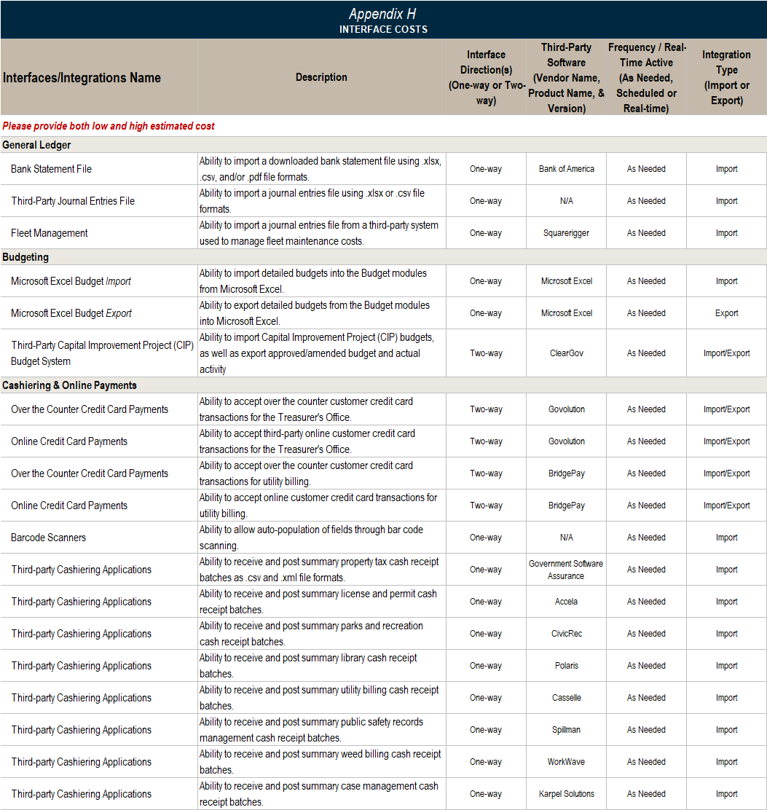

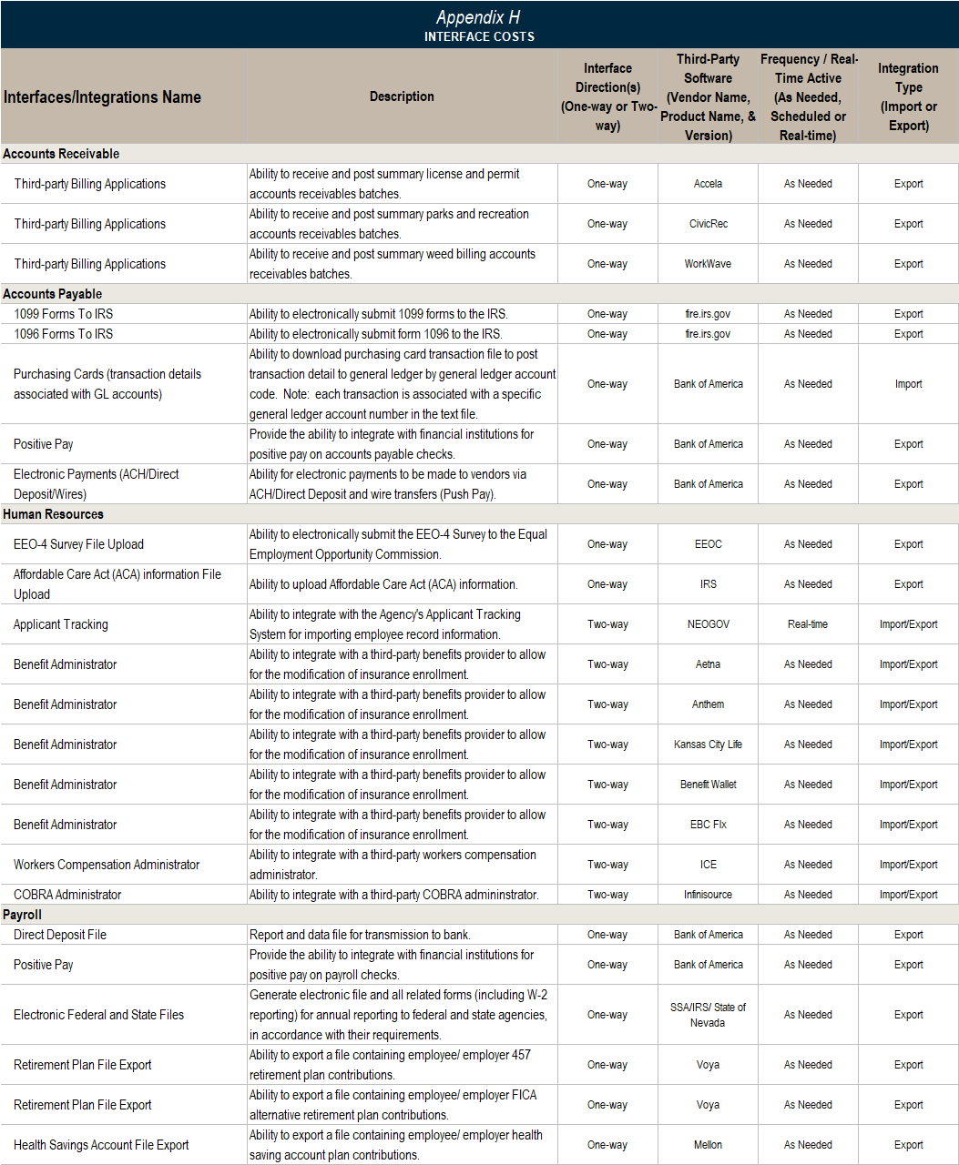

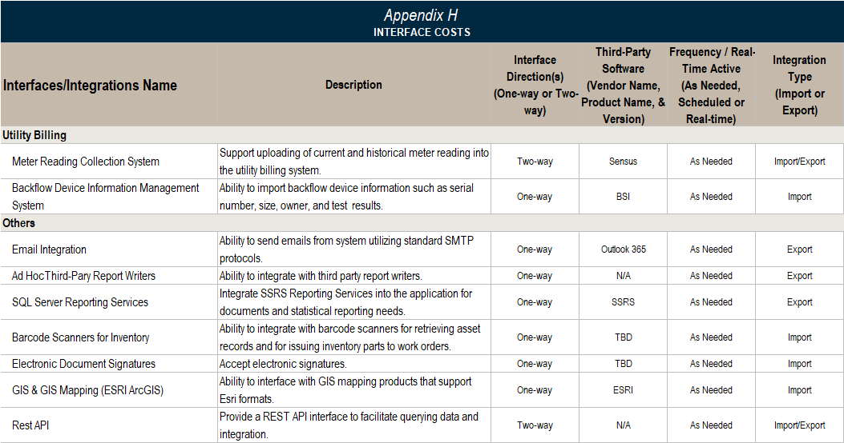

- Cost Considerations
Include initial one-time costs for hardware (if applicable), implementation, training, software licensing, travel, and related costs, etc. with the price proposal. See electronic price proposal form Section 5 (Appendices G1 and G2).
Recurring annual costs should be described in the proposal, clearly stating what is included (e.g., application upgrades, state and/or federal reporting requirements, hours of support, etc.), in Section 5 (Appendices G1, G2 and H). Please be sure to specify whether Annual Maintenance Costs are included in year one of the proposal term.
For SaaS or vendor hosted proposals, please incorporate a five-year term.
The expectation of all vendors responding to this RFP is to provide all necessary pricing without any hidden or unexpected costs.
- Mobile Field Computing
Please describe your solution’s mobile field computing options, including full application access through secure wireless connectivity (i.e., no vendor software required), mobile field application for use with laptops, or mobile field applications with use of tablets (e.g., iPads, Surface, etc.).
- Maintenance and Support
Please describe all support services available from your company in Section 5 (Appendix B). Specifically address the following issues:
- Normal hours of availability
- Online support information
- Online chat
- Remote system access capabilities
- Access via toll-free 800 number
- Costs
- Quality assurance program(s)
- Other support services
- Service-Level Agreements (SLA) – Response time (by priority or severity levels), escalation processes, and other metrics
- Implementation Methodology
Please describe your implementation methodology with milestones and timeframe. Include a preliminary implementation schedule for all applications, including the required time for system and application training, program/user acceptance testing, interfaces/integrations, and data conversion. Please include how you expect to sequence the installation of the various applications or application groupings.

- Conversion Costs
The County anticipates electronic data conversions, depending on cost. Please include an estimated range of costs for data conversions for each application, if available, and a description of data that would be typically converted including whether summary or detailed data conversion is being proposed. Costs for proposed data conversion are to be included (Section 5, Appendix I).
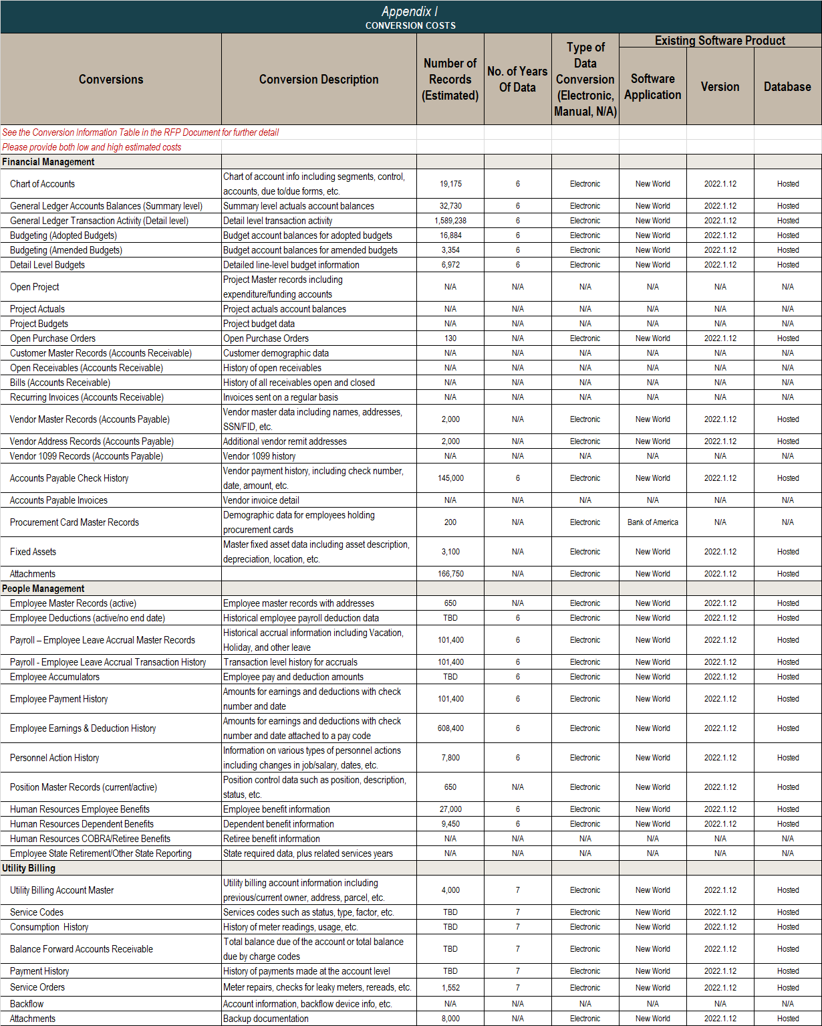
- Training and Education
Please describe your consulting and training options, including classroom (on site and off site), online (group and self-paced), training videos, and manuals. Include training for all required staff and users. Include ongoing training and user support group training options. Please refer to Appendices G1 and G2 to provide the pricing for this service.
- Project Management
The County will provide a designated project manager and expects the vendor to do the same. Please include recommended vendor project management costs (Section 5, Appendices G1 and G2) in the proposal and describe, in detail, services to be provided. The County reserves the right to accept or reject changes in vendor project management personnel.
- Subcontractor and Third-Party Relationships
Please describe any subcontractor relationships and/or third-party providers that will be used for this implementation.
Note: If a vendor chooses to partner with a third-party vendor to address some requirements, this must be clearly stated in the response. Be specific when describing applications and the third-party vendor-solution provider. Third-party vendors will be required to demonstrate their portion of the application solution along with all other required information being provided by the prime vendor.
- Customer Implementation Responsibilities
Please describe and/or provide a list of the typical customers’ implementation responsibilities.
- Sample User and Technical Manuals & Other Documentation
Please provide sample pages for the following:
- Sample Application User Manual
- Sample Application User Online Help Documentation
- Sample Technical User Manual
- Sample Technical User Online Help Documentation
- Sample Training Syllabus
- Sample Section of a Detailed Implementation Project Schedule
- Vendor/Reseller Information
Please provide all information related to your company as requested in RFP Section 5 (Appendices B, C, & D). In addition, specifically address the following issues:
- Describe your research-and-development approach and process.
- If you are a software reseller/partner, please provide the same company, customer demographics, and reference information for your specific company in addition to the software vendor’s information (see Section 5, Appendices B, C, D, and E).
- If your proposed solution belongs to a parent/consolidation company, only provide customer base figures and references for the proposed solution (see Section 5, Appendices D and E).
- Technology Direction
Please describe short-, medium-, and long-term direction regarding major changes in architecture, database, platforms, languages, etc.
- Vendor Financial Information
Short-listed vendors may be required to provide copies of your organization’s last three (3) years of audited financial statements, including any pending litigation, in a confidential manner to the County. Please do not send financial statements with your proposal.
- User Groups
Provide information regarding organized user groups, including frequency and location of user group meetings. Also, indicate who conducts the meetings and who is responsible for establishing meeting agendas. Please also describe a local (state or regional) user groups or meetings.
- References and User Base
Please provide references for a minimum of ten (10) completed projects of similar scope and nature to the County, preferably within the same region and that have gone live within the last three (3) years.
A reference worksheet is provided in Section 5 (Appendix E).
Please provide total number of customers (software provider and reseller, if applicable) for the applications according to the demographic request worksheet provided in Section 5 (Appendix D).
If your proposed solution belongs to a parent/consolidation company, only provide customer base figures and references for the proposed solution (see Section 5, Appendices D and E).
Additionally, please provide an organization name list of all active customers within the state of Nevada. Contact information is not necessary.
Lastly, please provide the number of new customers (original go-lives) implementing the proposed applications in each of the last three (3) years.
- Volumes
The tables below summarize the estimated volumes of transactions and records associated with the application processing requirements and preliminary conversion requirements.
- User License Information
Description¹ | Quantity
Concurrent Users | 140
Unique Full-User ID Licenses | 126
Unique Inquiry-Only User ID Licenses | 14
¹See the table under the “User Access Requirements by Module” of Section 3 Specific Response Requirements for user access requirements by individual module.
- Volumes Information

Volume Description | Quantity / Estimate Transactions
General Ledger
No. of Funds | 104
No. of GL Accounts | 2,991
No. of Bank Accounts | 16
Budgeting
No. of Budget Transfers/Amendment (Yearly) | 220
No. of Budget Units | 53
No. of Budget Levels/Versions | 6
Current Year General Fund Budget | $53,454,378
Current Year Capital Improvement Plan (CIP) Budget | $9,901,302
Current Year Total Budget | $117,234,814
Projects & Grants Management
No. of Projects/Programs (Active) | 125
No. of Grants (Active) | 30
Requisitions & Purchasing
No. of Purchase Orders | 300
Accounts Payable
No. of Vendors (Active) | 2,000
No. of A/P Invoices (Yearly) | 24,167
No. of A/P Checks (Yearly) | 10,483
No. of Employee-use Credit Cards | 177
Check Run Frequency | Weekly
Accounts Receivable
No. of Master Customer Records (Active) | 66
No. of Accounts Receivable Invoices | 160
Cash Handling/Management
No. of Annual Cash Receipt Transactions (est.) | 50,000
No. of Cashiering Locations (counters) | 26
No. of Cashiering Terminals | 21
No. of Annual Online Payment Transactions | 14,399
Amount of annual revenue collected from all cashiering transactions (est.) | $147M
Fixed Assets
No. of Fixed Assets | 3,082
No. of Asset Additions | 120
No. of Assets Retired | 90
Human Resources
No. of New Hires | 200+
No. of Full-Time Employees | 500
No. of Permanent Part-Time Employees | 69
No. of Seasonal Employees | 12
No. of Personnel Actions (e.g., Disciplinary, FMLA Requests, wage increase, etc.) | 2,000
No. of Benefits Enrollees | 480
No. of Benefit Plans | 15
Pay Period Frequency | Bi-weekly
Utility Billing
No. of Customer Utility Accounts | 4,274
Utility Billing Frequency | Monthly
No. of Utility Billing Cycles | 1
No. of Annual Online Payments | 16,336
No. of Field Service Order Staff | 5
No. of Annual Field Service Orders | 300

- Proposal Forms & Supporting Information
This section of the RFP explains the required proposal forms and other supporting information designed to assist the vendors in their response.
- Vendor Electronic Response Files
The multi-tab Excel spreadsheet files contain all appendices listed below. Appendices must be filled in and submitted using these electronic forms (multi-tab Excel files) and must also be printed and included in your proposal.
Douglas County ERP-UB - RFP Feature/Function Requirements Appendix A file (Excel)

RFP Appendix A1 – Financial Management Feature/Function Workbook Tabs

RFP Appendix A2 – Human Management Feature/Function Workbook Tabs

RFP Appendix A3 – Utility Billing Management Feature/Function Workbook Tabs

RFP Appendix A4 – Other Management Feature/Function Workbook Tabs
Douglas County ERP-UB - RFP Appendices B-J file (Excel)

RFP Appendix B Vendor Profile

RFP Appendix C Vendor Financial Information

RFP Appendix D Vendor Customer Base

RFP Appendix E Vendor References

RFP Appendix F Vendor General System

RFP Appendix G1 On-Premise Project Costs

RFP Appendix G2 Cloud-Hosted Project Costs

RFP Appendix H Interface Costs

RFP Appendix I Conversion Costs

RFP Appendix J Modification Costs
- Proposal Instructions
This section outlines the information that is requested to be included in your proposal. Please include a table of contents at the beginning of your proposal clearly outlining the contents of each section.
- General Proposal Instructions
Software features, functions, and capability information should also be submitted electronically using the forms and instructions contained in the RFP.
Response instructions are contained in Sections 3, 4, 5, and 6 of the Request for Proposals (RFP) document.
Section 5 of the RFP contains feature/function and other information worksheets. Please complete these worksheets using the electronic forms (Excel format) and as directed in the RFP instructions. The electronic forms have been locked where possible to ensure the integrity of the information. Effort has been made to keep the RFP and feature/function listing as brief as possible.
The proposal should include all costs associated with training, implementation, hardware specifications, interface estimates, file-conversion assistance, custom modification estimates, annual maintenance, and support.
- Send the intent to propose notification to Terri Willoughby, Chief Financial Officer (County Point of Contact, “POC”) by email to twilloughby@douglasnv.us no later than August 14, 2023.
- Send any questions related to this RFP in writing to the POC via email no later than August 21, 2023. Only written questions submitted by email by the above-stated date will be accepted.
- Please submit your proposal by 4:00 PM (PT) September 8, 2023, as follows:
  - One (1) copy emailed to the POC at twilloughby@douglasnv.us
  - One (1) copy electronically on a flash drive to:
Terri Willoughby
Chief Financial Officer
Douglas County
1594 Esmeralda Ave
Minden, NV 89423
Requests for extension of the submission date will not be granted. Vendors submitting proposals should allow for normal mail or delivery time to ensure timely receipt of their proposal.
Responses to the Specific Proposal Requirements identified in Section 3 MUST be completed and indexed appropriately. In addition, all forms and checklists identified in Section 5 must also be included. Failure to include any of the requested information within your proposal may result in rejection/disqualification.
- Proposal Format
Proposals should be made in accordance with the RFP format provided herein, with all blank spaces in the appendices properly filled in. Numbers shall be stated in whole dollars.
Please provide the following sections, as a minimum:
- Executive Summary
- Understanding of Project Objectives
- Specific Proposal Requirements (see Section 3)
- Detailed Proposal and Contractual Requirements (including exceptions taken to any RFP requirement)
- Remaining Appendices not included in another section
Proposals shall be addressed as indicated. A duly authorized official representing the vendor must sign all proposals.
Modification of proposals will be acceptable only if delivered in writing to the place of the proposal prior to the proposal due date and time. Should the vendor find discrepancies in the RFP, detect omissions from the RFP, or be in doubt as to the meaning of any point, they shall at once notify Terri Willoughby, Chief Financial Officer (County Point of Contact, “POC”) by email to twilloughby@douglasnv.us. The County will send written instructions/clarifications to all vendors. If the proposal and specifications are found to disagree after the contract is awarded, the County shall be the judge as to which was intended.
Vendors are prohibited from contacting any County officials or employees regarding this Request for Proposals. All questions must be directed, in writing, to Terri Willoughby, Chief Financial Officer (County Point of Contact, “POC”) by email to twilloughby@douglasnv.us. Failure to comply with this provision may result in rejection/disqualification of your proposal.
No negotiations, decisions, or actions shall be executed by the vendor as a result of any discussions with any of the County officials, employees, and/or consultant. Only those transactions provided in written form from the County may be considered binding. In addition, the County will only honor transactions from vendors which are written and signed.
The County reserves the right to terminate the selection process at any time and to reject any or all proposals. The contract will be awarded to the vendor whose overall qualifications best meet the requirements of the County.
The County shall not be liable for any pre-contract costs incurred by interested vendors participating in the selection process.
The contents of each vendor's proposal to the County, including technical specifications for hardware and software, purchase and lease prices, and hardware and software maintenance fees, shall remain valid for a minimum of 180 calendar days from the proposal due date.
All proposals should include copies of all sample contracts for hardware (if applicable), systems software, application software, hardware maintenance (if applicable), and software support. Please note that all contracts will be subject to negotiation between the County and the selected vendor.
This RFP and the selected vendor’s proposal, including all representations, warranties, and commitments contained in the proposal and related correspondence shall be contractual obligations included in the written final contract for services, equipment, and software.
- Disclosures & Contractual Requirements
Please note that any exceptions to the following requirements, as well as other sections of this Request for Proposals, should be addressed in a separate section of the vendor’s proposal.
- Bulletins and Addenda
Any bulletins or addenda to the specifications contained in this RFP issued during the period between issuance of the RFP and receipt of proposals are to be considered covered in the proposal, and in awarding a contract, they will become a part thereof. The vendors shall acknowledge receipt of bulletins or addenda in their proposal cover letter.
- Rejection of Proposals
Proposals that are not prepared in accordance with these instructions to vendors may be rejected or disqualified. If not rejected, the County may demand correction of any deficiency and accept the corrected proposal upon compliance with these instructions to proposing vendors.
- Acceptance of a Proposal
Proposals submitted are offers only, and the decision to accept or reject will be based on the quality, reliability, capability, reputation, and expertise of the proposing vendors.
The County reserves the right to accept the proposal that is, in its judgment, the best and most favorable to the interests of the County, to reject the lowest-price proposal, to accept any item of any proposal, to reject any and all proposals, and to waive irregularities and informalities in any proposal submitted or in the RFP process, provided, however, that the waiver of any prior defect or informality shall not be considered a waiver of any future or similar defect or informality. Proposing vendors should not rely upon or anticipate such waivers in submitting their proposal.
- Insurance
Prior to commencement of the Services, the Contractor shall take out and maintain, at its own expense, and shall cause any subcontractor with whom Contractor uses for the performance of Services to take out and maintain, the following insurance until completion of the Services or termination of the Agreement, whichever is earlier, except as otherwise required by the “Minimum Limits of Insurance” section below. All insurance shall be placed with insurance companies that are licensed and admitted to conduct business in the state of Nevada and are rated at a minimum with an “A:VII” by A.M. Best Company, unless otherwise acceptable to the County. The amount of such insurance shall be at least for the limits specified below:

Coverage | Limits of Liability
Worker’s Compensation | Statutory
Professional Liability/Errors & Omissions | $2,000,000
Cyber Liability | $2,000,000
Employer’s Liability | $1,000,000
General Liability Per Occurrence | $1,000,000 Each Occurrence
General Liability Aggregate | $2,000,000
Automobile Combined Single Liability Limit | $1,000,000
Umbrella Liability – extends over general liability, auto liability, and employers’ liability | If applicable (Umbrella or Excess coverage can be used to meet the minimum limits of insurance)
The Contractor shall list the County, its officers, officials, employees, and volunteers as additional insured with respect to general liability and automobile. Additionally, Contractor shall also obtain any endorsements that may be necessary to affect waiver of subrogation for the aforementioned coverages.
- Vendor Demonstrations
Vendors may be requested, at no cost to the County, to demonstrate the proposed software and hardware systems at a mutually agreeable date and site.
- Qualifications
It is expected that the proposing vendor has the requisite experience, ability, capital, facilities, organization, and staff to enable the proposing vendor to perform the work successfully and promptly, and to commence and complete the work within the proposed price and time frame.

Acknowledgments
By submitting a proposal, a proposing vendor acknowledges and agrees to each of the following:
Reliance. The County is relying on all warranties, representations, and statements made by the vendors in their proposals.
Reservations of Rights. The County reserves the right to reject any and all proposals, reserves the right to reject the lowest priced proposal, and reserves such other rights as are set forth in the instructions to proposing vendors.
Acceptance. If a vendor’s proposal is accepted by the County, the vendor shall be bound by each and every term, condition, and provision contained in the Request for Proposals, the vendor’s proposal, and in the final contract to be negotiated between the selected vendor and the County.
Remedies. Each of the rights and remedies reserved to the County in this Request for Proposals shall be cumulative and additional to any other or further remedies provided in law or equity.
Severability. The provisions of this Request for Proposal shall be interpreted when possible to sustain their legality and enforceability as a whole. In the event any provision of this Request for Proposal shall be held invalid, illegal, or unenforceable by a court with jurisdiction in the state of Nevada, in whole or in part, neither the validity of the remaining part of such provision, nor the validity of any other provisions of this Request for Proposal shall be in any way affected thereby.
Amendments. No modification, addition, deletion, revision, alteration, or other change in this Request for Proposal shall be effective unless and until such change is reduced to writing and executed and delivered by the County to the prospective vendors.

